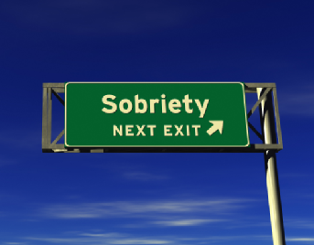
Understanding the Three Circles

The Inner Circle
Inside this circle, we write down each one of the compulsive sexual behaviors from which we feel it necessary to abstain. Everything inside this circle is off limits for us. These are the behaviors that destroy our lives. One day at a time, we abstain from all the behaviors we have placed in this circle. Our “sobriety” is counted by the length of time we are able to abstain from those behaviors. Engaging in any of those behaviors would be considered a “relapse” and the addict’s sobriety time would start over. Please note that it is the addict’s “sobriety time” and not “recovery time” that starts over after a relapse. It is important for all recovering addicts to remember that a relapse does not mean that they have lost their recovery. We find in the program that all challenges, including the possible relapse, are stepping stones along the path of our recovery.
The Middle Circle
“Progress not perfection” is the goal of recovering sex addicts. Many of us have found our quest for perfectionism in our lives to be a trigger for our addiction and even a barrier from reaching out for help. Because we are human, we invariably fall short of our lofty ideals, and then sink into a destructive cycle of self-condemnation, shame and eventually, acting out in our Inner Circle. There are some behaviors while although not sexual in nature or a direct behavior that we work to abstain from, if not addressed will eventually lead us back to our Inner Circle. The Middle Circle is where we place behaviors of which we are uncertain. These are sometimes referred to as “boundary behaviors”. While prostitution may be in a member’s Inner Circle, the act of cruising an area known to have prostitution could be considered a Middle Circle or boundary behavior. Think of it as a kind of “danger zone” that helps addicts to realize they are in a situation that although would not be considered a relapse, is still a concern of leading to relapse. It is when a member finds themselves in a Middle Circle activity or behavior that they should use the tools of the program by contacting their sponsor, attending the nearest meeting, and/or working to remove themselves from the situation or behavior to help avoid a relapse.
The Outer Circle
Just as we are to work to abstain from the behaviors listed in our Inner Circle, so too are we to work towards the behaviors listed in our Outer Circle. In the Outer Circle we list behaviors that bring recovery and are to be encouraged, praised, and practiced. Some examples that members choose to put into their Outer Circle are working the twelve steps, attending regular SAA meetings, staying in regular contact with their sponsor, working on better communication with their spouse or partner, engaging in activities that lead to better physical health such as playing a sport or going to a gym, and sharing their recovery with other recovering sex addicts. We aim to not only abstain from the compulsive sexual behaviors that destroyed our lives, but also to practice healthy behaviors that are self nurturing and bring us serenity and joy.
More information can be found in the SAA pamphlet – Three Circles – Defining Sexual Sobriety in SAA

