SAA New orientation Open Meeting
Every Saturday
A MEETING FOR NEWCOMERS AND THOSE INTERESTED IN FINDING OUT MORE ABOUT SAA

Come join us to find out more about Sex Addicts Anonymous (SAA)

Every Saturday @ 2:00 pm  @ The Outer Circle Club  1500 North Post Oak Rd – Suite 150  N Post Oak @ Hempstead, across from NW Mall | 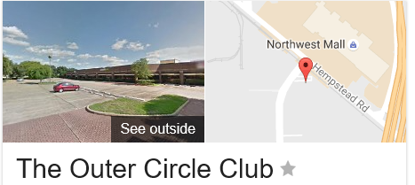
This is a 90-minute orientation meeting open to addicts as well as newcomers who think they might suffer from sexual addiction. The meeting is also open to partners and loved ones of the addict as well as clergy, students and professionals who are looking to learn more about the SAA program and sex addiction. This is not a therapy or counseling meeting but rather an orientation meeting aimed at introducing the fundamentals of the SAA program. The format will include readings from the SAA meetings and introductions of the different meeting formats followed by a Q&A discussion. Pamphlets and other free reading material will be available to those who are interested.
This is an open meeting so if you feel uncomfortable in attending but would still like to learn more about the meeting and the program; feel free to call (281) 656-1668 or email us at saa.houstonopen@gmail.com for more information.

www.houstonsaa.org

